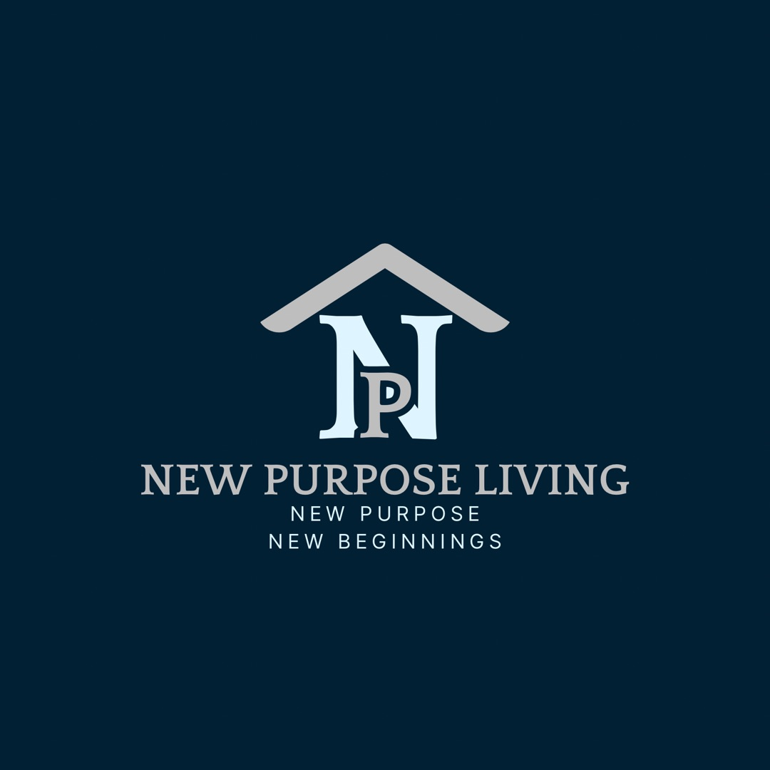
NEW PURPOSE LIVING LLC
Residential Sober Living Application & Intake Packet
PAGE 1 — APPLICATION
Applicant Information
Full Name: ______________________________________________
Preferred Name: ______________________________________________
Phone Number: ______________________________________________
Email Address: ______________________________________________
Date of Birth: ______________________________________________
Current Address: ______________________________________________
City/State/Zip: ______________________________________________
How did you hear about us?: ______________________________________________
Emergency Contact
Name: ______________________________________________
Relationship: ______________________________________________
Phone Number: ______________________________________________
Alternate Phone: ______________________________________________
Recovery Status
Primary substance(s) used: ______________________________________________
Date of last use: ______________________________________________
Have you completed treatment before? If yes, where and when: ______________________________________________
Do you have a sponsor or recovery support person? If yes, name/contact: ______________________________________________
Have you completed detox? ☐ Yes ☐ No
Work and Income
Are you currently employed? ☐ Yes ☐ No
Employer: ______________________________________________
Monthly income: ______________________________________________
Do you have a source of income to pay housing fees?: ______________________________________________
Legal Information
Are you currently on probation or parole? ☐ Yes ☐ No
If yes, explain: ______________________________________________
Do you have any upcoming court dates? ☐ Yes ☐ No
If yes, explain: ______________________________________________
Are there any current charges or legal issues we should know about? ☐ Yes ☐ No
If yes, explain: ______________________________________________
Medical and Mental Health
Do you take any prescribed medication? ☐ Yes ☐ No
If yes, explain: ______________________________________________
Are you on MAT? ☐ Yes ☐ No
If yes, explain: ______________________________________________
Do you have any medical conditions we should know about? ☐ Yes ☐ No
If yes, explain: ______________________________________________
Do you have any mental health diagnoses we should know about? ☐ Yes ☐ No
If yes, explain: ______________________________________________
Tell Us About Yourself
____________________________________________________________________
____________________________________________________________________
____________________________________________________________________
____________________________________________________________________
Why do you want to live here?
____________________________________________________________________
____________________________________________________________________
____________________________________________________________________
____________________________________________________________________
Authorization and Signature
I certify that the information provided is true and complete to the best of my knowledge. I understand that completion of this application does not guarantee acceptance.
Applicant Signature: ______________________________________________
Printed Name: ______________________________________________
Date: ______________________________________________

PAGE 2 — SCREENING ACKNOWLEDGMENT
Screening Questions
Have you ever been convicted of a violent offense? ☐ Yes ☐ No
Have you ever been convicted of assault? ☐ Yes ☐ No
Have you ever been convicted of sexual offenses? ☐ Yes ☐ No
Have you ever been convicted of child abuse? ☐ Yes ☐ No
Have you ever been convicted of armed robbery? ☐ Yes ☐ No
Have you ever been convicted of drug trafficking or distribution? ☐ Yes ☐ No
If yes to any, explain: ______________________________________________
Additional Background Information
Have you ever been discharged from sober living before? ☐ Yes ☐ No
If yes, explain: ______________________________________________
Have you ever relapsed while in a recovery residence? ☐ Yes ☐ No
If yes, explain: ______________________________________________
Is there anything else we should know before reviewing your application?
____________________________________________________________________
____________________________________________________________________
Consent to Verify Information
I authorize New Purpose Living LLC to verify the information in this application, including references, employment, recovery supports, and legal status when necessary for housing placement.
Applicant Signature: ______________________________________________
Date: ______________________________________________

PAGE 3 — WELCOME / INTAKE PACKET
Welcome to New Purpose Living LLC
We are glad you are here. Our home is designed to provide a safe, stable, and supportive environment for individuals committed to sobriety, accountability, and personal growth.
Purpose of the home
- To support residents in maintaining sobriety.
- To encourage responsibility, structure, and healthy habits.
- To provide a respectful, drug-free living environment.
- To help residents transition into long-term independence.
Resident expectations
- Remain drug- and alcohol-free.
- Follow all house rules.
- Submit to random drug and alcohol testing.
- Attend recovery meetings as required.
- Maintain employment or actively seek employment.
- Treat staff, residents, and neighbors with respect.
- Keep their room and shared spaces clean.
- Pay housing fees on time.
- Report relapse, legal issues, or emergencies immediately.
Smoking/vaping policy: ______________________________________________
Curfew time: ______________________________________________
Weekend curfew time: ______________________________________________
Visitors allowed? If yes, hours and rules: ______________________________________________

PAGE 4 — HOUSE RULES
House Rules
1. No alcohol or illegal drugs on or off the property while residing here.
2. No drug paraphernalia, weapons, violence, theft, or threats.
3. No tampering with drug or alcohol testing.
4. No overnight guests without permission.
5. No disrespect, intimidation, fighting, or harassment.
6. Quiet hours must be followed.
7. All residents are responsible for keeping shared areas clean.
8. Residents must communicate honestly with staff.
9. Residents must follow assigned chores and meeting requirements.
10. Failure to follow house rules may result in warnings, suspension, or discharge.
Acknowledgment of House Rules
I have read, understood, and agree to follow the house rules of New Purpose Living LLC.
Resident Signature: ______________________________________________
Printed Name: ______________________________________________
Date: ______________________________________________

PAGE 5 — MEDICATION AND HEALTH
Medication Policy
- All medications must be disclosed at intake.
- Prescription medication must be taken as directed.
- Medications may need to be stored securely.
- Residents must not share medications.
- Any change in medication must be reported.
Health Emergency Information
Primary doctor: ______________________________________________
Clinic/office phone: ______________________________________________
Preferred hospital: ______________________________________________
Allergies: ______________________________________________
Medical Emergency Authorization
In the event of an emergency, I authorize staff to seek emergency medical care if needed.
Resident Signature: ______________________________________________
Date: ______________________________________________

PAGE 6 — RELEASE OF INFORMATION
Release of Information
I authorize New Purpose Living LLC to communicate with the following, as needed for housing placement and ongoing recovery support:
- Treatment providers.
- Probation or parole officers.
- Sponsors or recovery supports.
- Employers.
- Medical providers.
- Other approved contacts.
Name(s) of approved contacts: ______________________________________________
Resident Signature: ______________________________________________
Date: ______________________________________________

PAGE 7 — FINAL AGREEMENT
I understand that this sober living home is not a treatment facility, but a recovery-oriented residence. I understand that acceptance and continued residence depend on compliance with all rules, payment requirements, and safe behavior.
I understand that false information on this packet may result in denial or discharge. I also understand that completion of this packet does not guarantee admission.
Resident Signature: ______________________________________________
Printed Name: ______________________________________________
Date: ______________________________________________

